# Software Upgrading Guideline

# 1、Driver Installation

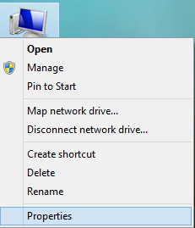1、Choose my PC on the desk – click right button – choose “Properties” :

2、Check the PC operating system( 32-bit or 64-bit ):

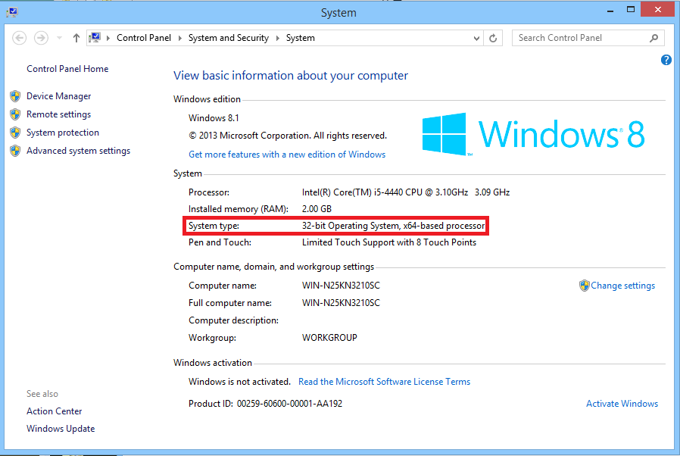

3、Open the file “CP210x_VCP_Windows_driver”: if the operating system is 32-bit, double-click “ CP210xVCPInstaller_x86.exe” to install the driver; if it is 64-bit, double-click “CP210xVCPInstaller_x64.exe” to install the driver. Then click “Next” to next step:

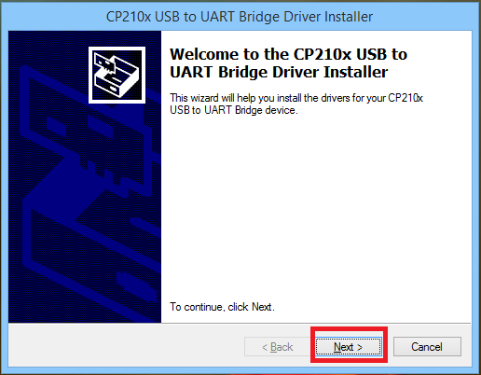

4、choose “I accept this agreement” - click“Next”:

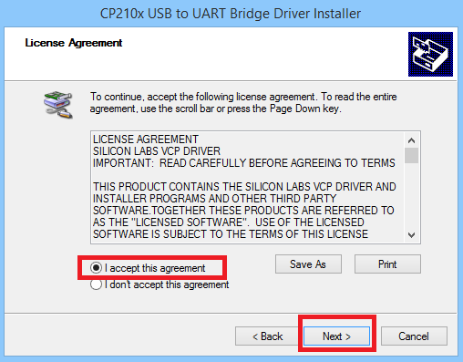

5、Installing- click “Finish” when finished:

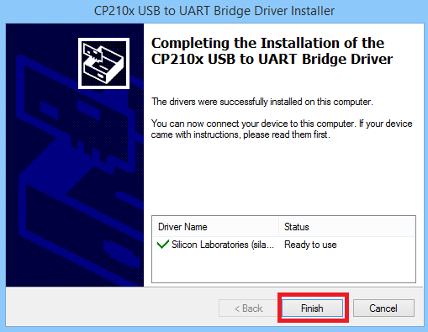

# 2、Distinguish the Type of Device

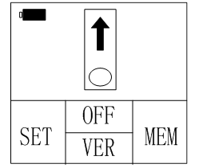1、Turn on the device - main interface – click OK(VER) button:

2、 Check the version of device: if the version is Vx.x.xx，it is V1 device. Upgrading procedure can refer to V1 software upgrading SOP; if it is V2.x.x.xx, then it should be V2 device. Upgrading procedure can refer to V2 software upgrading SOP:

 

V1 V2

# 3、V1 Software Upgrading

**Preparation for upgrading：**

Ensure qLabs device has been shut off；

Ensure no back-up battery in the qLabs device；

Ensure qLabs device has connected normally with PC via eCable；

1、Open the file “PTLoader1.4” – double-click “PTLoader1.4.exe” - PTLoader1.4 software interface。Following is the serial port connect information. Click “Open File” to choose file:

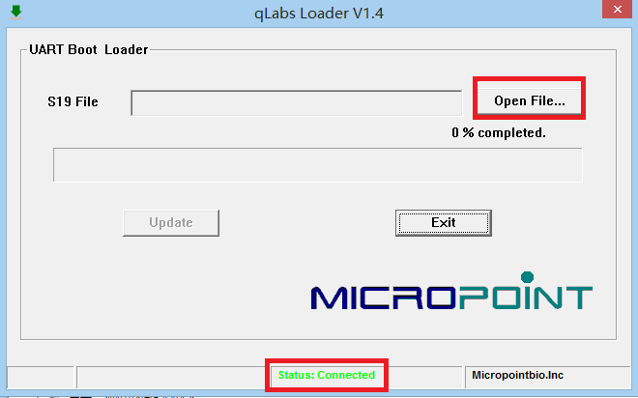

2、Select and open the file “qLabsV4.6.11.S19” :

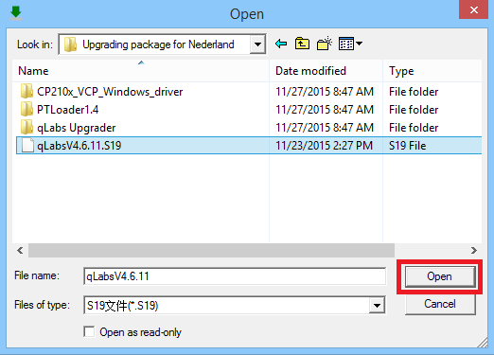

3、Click“Update”to start upgrading:

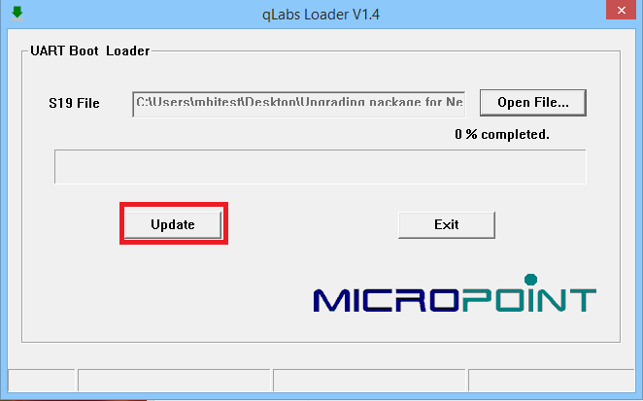

4、Under shut off status, keep pressing “OK” on the device and turn on the power supply – release the button until the blue progress bar comes out:

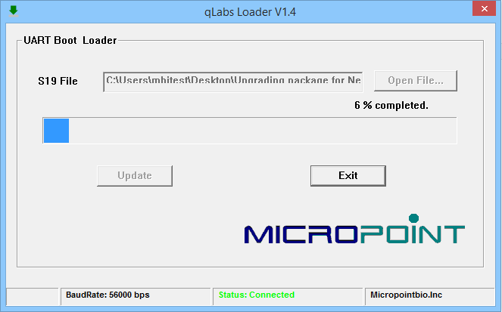

5、When the progress is 100% completed, qLabs device automatically restart – after restart, check the current software version to ensure the new version has been installed:

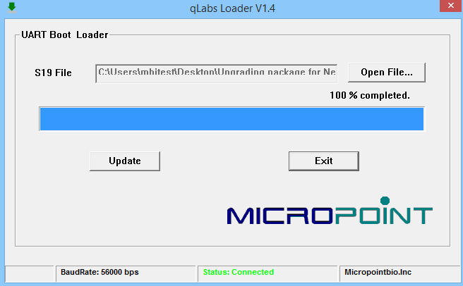

6、NOTICE: DO NOT shut down the software if several devices needing to be upgraded, only repeat the steps from 3rd to 5th.

# 4、V2 Software Upgrading

**Preparation for upgrading:**

Ensure the power is sufficient when using battery powered meter.

Ensure the qLabs meter is powered on.

Ensure the qLabs meter is connected to the computer via eCable.

Ensure the computer memory is big enough to complete this upgrade.

1、Open the file “qLabs Upgrader” – double click “qLabs Upgrader.exe” - qLabs Upgrader V1.0 software interface. Following is the serial port connect information. Click “Browse” to choose file:

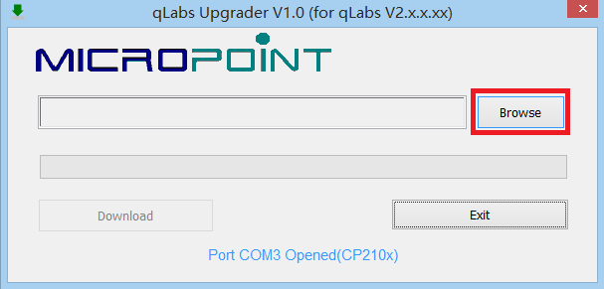

2、Select and open the file “qLabs V2.7.0.12.bin”:

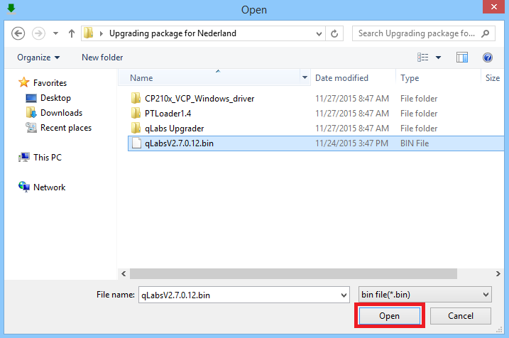

3、Click “Download” , qLabs device will appear the following interface. Choose “YES” to download；choose“NO”to exit。( 3~4mins for downloading):

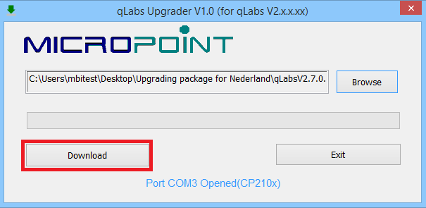

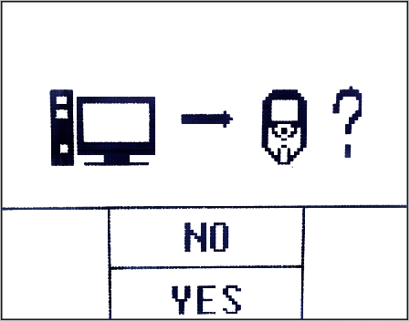 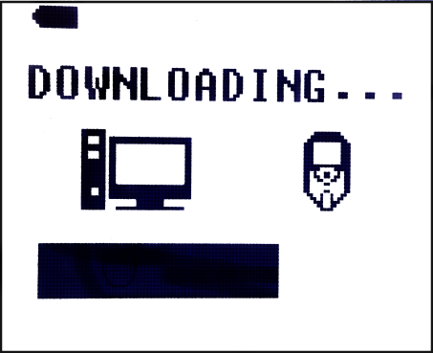

4、Downloaded - qLabs Upgrader V1.0 shows “upgrade download finished” - click“OK”:

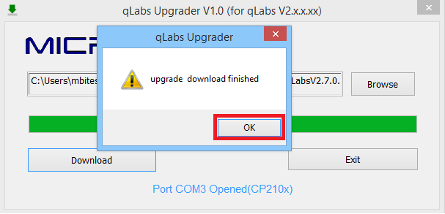

5、After the completion of downloading, a prompt says “Restart now to finish upgrade” will appear (as shown in left image). If the user chooses “YES”, the meter will restart immediately and enter the “upgrading” screen (as shown in right image). If the user chooses “NO”, the meter will return to the main screen and start upgrade automatically next time when powered on. Please wait for 3 to 4 minutes to finish the upgrading process.

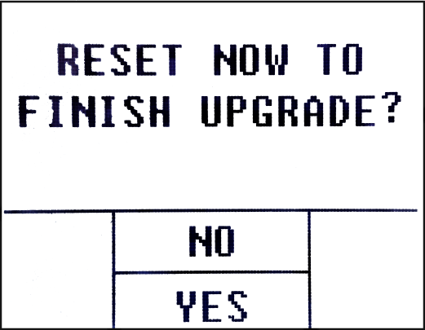 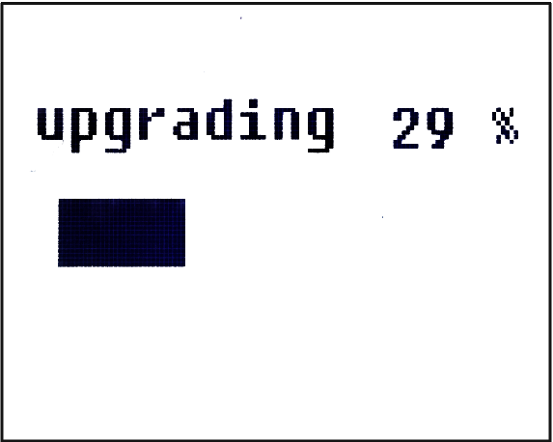

6、When finishing upgrading, the meter will enter the screen which prompts the user to insert the strip. The user can check the version of the current software.

7、NOTICE: DO NOT shut down the software if several devices needing to be upgraded, only repeat the steps from 3rd to 7th.

Notes:

1) Before clicking on “Download”, please make sure the qLabs meter is not performing upload, download, print and test (the strip hadn’t been inserted into the meter).

2) If Yes or No is not selected within 10 seconds after clicking on “Download”, the meter will exit the current screen.

3) The download process will be interrupted if “Upgrade failed: Download Timed out” screen pops up during downloading. Please check if the meter is connected successfully. Download again if no problem exists.

4) The upgrade package check will fail if “Upgrade failed: CRC Check fail” screen pops up after finishing the downloading. The meter will dispose of the upgrade package and the user can download again.